Question

1. Create tables - 15 Marks
   1. Make a student table
   2. Make a Library table
   3. Make a Fees table

Create table with proper relations.

Answer (a):

CREATE TABLE Student (

Roll CHAR(4) PRIMARY KEY,

Name VARCHAR(50),

Email VARCHAR(60),

Address VARCHAR(255),

Phone VARCHAR(15),

Age INT

);

(b):

CREATE TABLE Library (

BookName VARCHAR(50) PRIMARY KEY,

WhoHired_Roll CHAR(4),

FOREIGN KEY(WhoHired_Roll) REFERENCES Student(Roll)

);

(c):

CREATE TABLE Fees(

StudentRoll CHAR(4) PRIMARY KEY,

Fee INT,

FOREIGN KEY(StudentRoll) REFERENCES Library (WhoHired_Roll)

);

1. Add proper constraints with the No 1 question - 5 Marks  
   Answer:

CREATE TABLE Student (

Roll CHAR(4) PRIMARY KEY,

Name VARCHAR(50) NOT NULL,

Email VARCHAR(60) UNIQUE,

Address VARCHAR(255),

Phone VARCHAR(15) DEFAULT 'Not given',

Age INT CHECK(Age >= 10)

);

CREATE TABLE Library (

BookName VARCHAR(50) PRIMARY KEY,

WhoHired_Roll CHAR(4),

FOREIGN KEY(WhoHired_Roll) REFERENCES Student(Roll)

);

CREATE TABLE Fees(

StudentRoll CHAR(4) PRIMARY KEY,

Fee INT CHECK(Fee >= 0),

FOREIGN KEY(StudentRoll) REFERENCES Library (WhoHired_Roll)

);

1. Write the differences between data and information - 10 Marks  
   Answer:  
     
   Data is raw, it’s not stay organized. It’s just values, while information is organized and presentable.  
     
   Example of Data:  
    Mahmud  
    102  
    Hasan  
    01750000444  
    Khan  
    0489  
     
   Example of Information:

| **Name** | **Roll** | **Phone** | **Bank A/C** |
| --- | --- | --- | --- |
| Mahmud | 102 | 01750 | 4786 |
| Hasan | 103 | 01712 | 0357 |
| Khan | 104 | 01523 | 0489 |

1. In MySQL, Update and Delete query wasn’t executing, what was the reason and how to run those query? Write the code to enable the feature. (If you followed the class, you should know this). - 10 Marks  
     
   Answer:  
   For database security purposes in MySQL, Update and Delete query wasn’t executing.  
   To run those query we must disable security first, After running the query we should enable database security again.  
     
   – Enable to run Updata and Delete query

SET SQL_SAFE_UPDATES = 0;

– Disable to run Updata and Delete query

SET SQL_SAFE_UPDATES = 1;

**Example:**

SET SQL_SAFE_UPDATES = 0;

UPDATE student

SET Name = 'MD Mahmudul Hasan'

WHERE Roll = 1;

SET SQL_SAFE_UPDATES = 1;

Answer the following questions with this table data. Table name Employee.

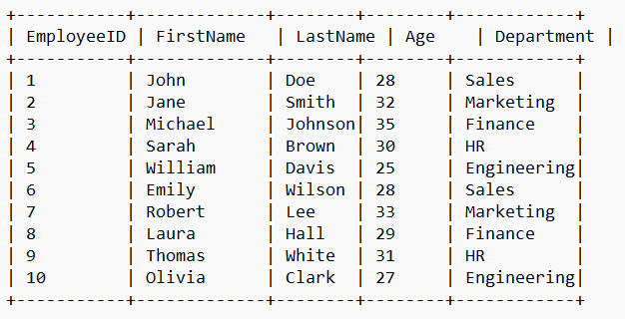

1. Write a query to show the distinct department names - 10 Marks  
   Answer:  
     
   SELECT DISTINCT Department  
   FROM Employee;

1. Write a query to show the LastNames of the employees sorted by descending ages - 10 Marks  
   Answer:  
     
   SELECT LastName

FROM Employee

ORDER BY LastName DESC;

1. Write a query to show the employee LastName whose age is greater than 30 and works in Marketing department. - 10 Marks

Answer:  
  
SELECT LastName

FROM Employee

WHERE Age > 30 AND Department = 'Marketing';

1. Write a query to select all the employees - 10 Marks

Answer:

SELECT *

FROM Employee;

1. Write a query to get employees whose names includes ‘son’ - 10 Marks  
   Answer:

SELECT *

FROM Employee

WHERE FirstName LIKE '%son%' OR LastName LIKE '%son%';

1. Write a query to get the engineers - 10 Marks

Answer:

FROM Employee

WHERE Department = 'Engineering';